**Unsupervised Imagine Classification**

**In QGIS**

**Practical Manual**

1. **Add raster data**

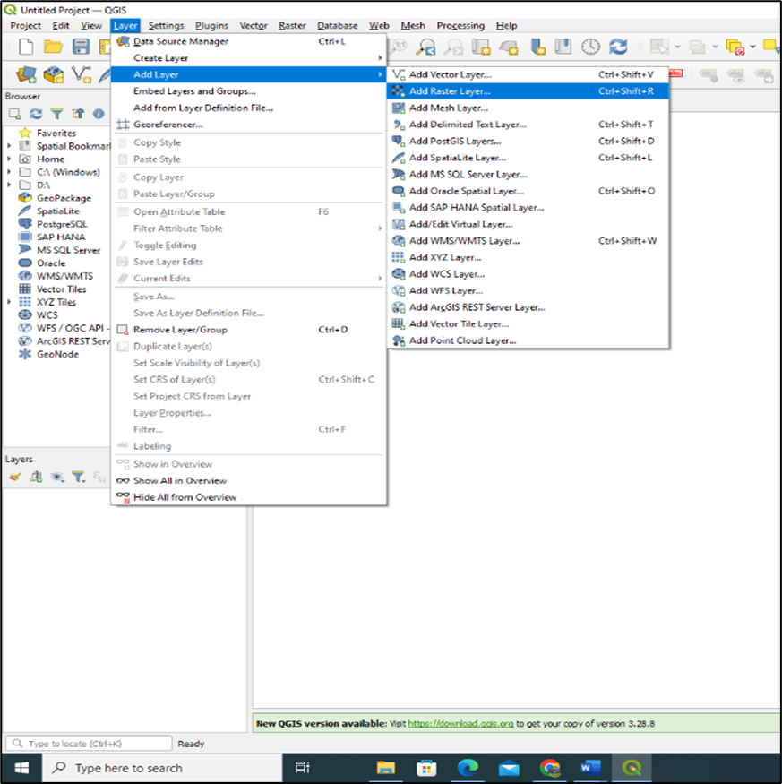To add raster data select **layer** on the menu, scroll down to **Add Layer** navigate to **Add Raster Layer**

From the Raster Data Source Management Tab, navigate to the directory you have saved your remotely sensed data. Leave File as the default Source Type.

NB: Make sure you do not save your data on the desktop or external memory stick. Your data should be saved in your C drive or any other partnioned drive in your computer. Avoid running many applications such as google chrome when using QGIS, it may slow your computer if your system has a lower processing capacity.

Start the SCP plugin and open band processing window. The multiband list and band set definition panels should be empty, if there are layers from the previous analysis exercises clear the two panels before you proceed.

After removing previous, refresh the multiband image list, use the drop-down menu to select the stacked image. Use the plus sign to add the band set to the Band set definition panel. After adding the band set, the individual bands within the stack should appear. Select clustering for unsupervised classification.

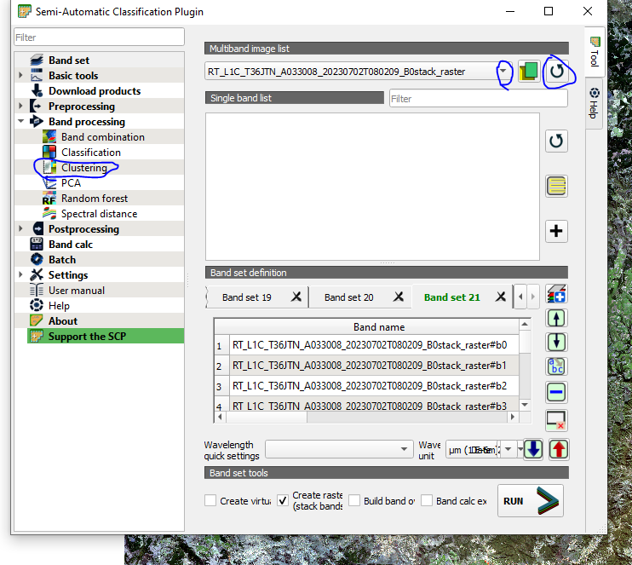

Select K-Means as your classification method. Adjust the parameters if there is need, you may choose to increase or reduce the number of classes and iterations.

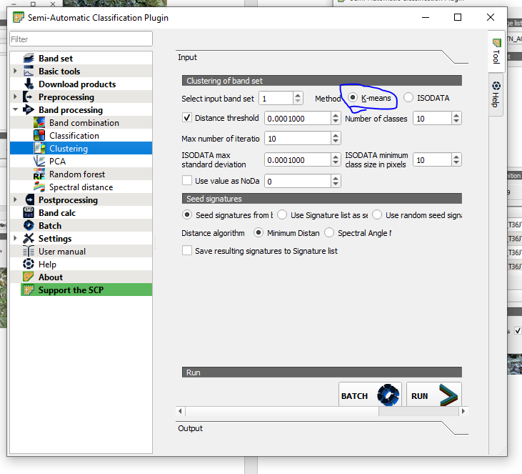

**Supervised classification**

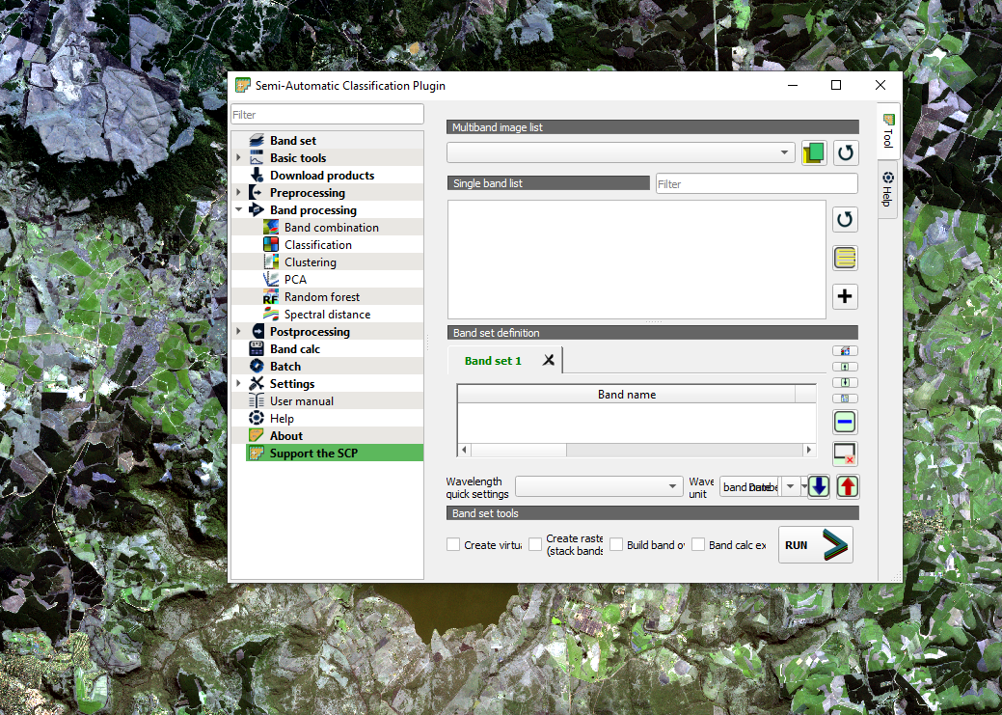

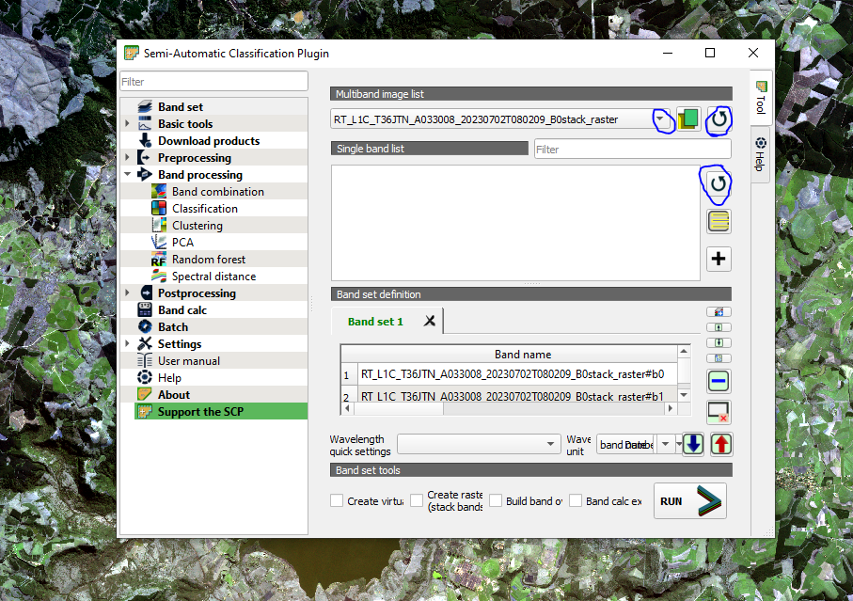

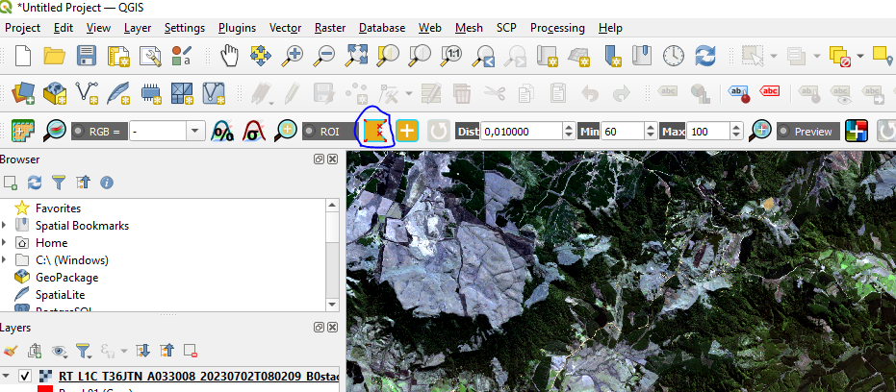

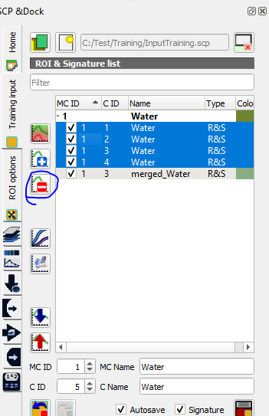

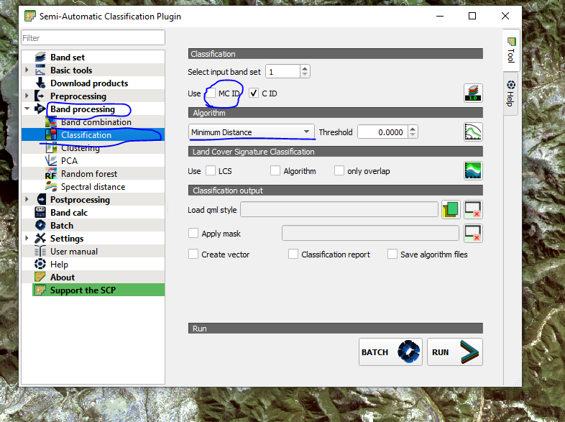

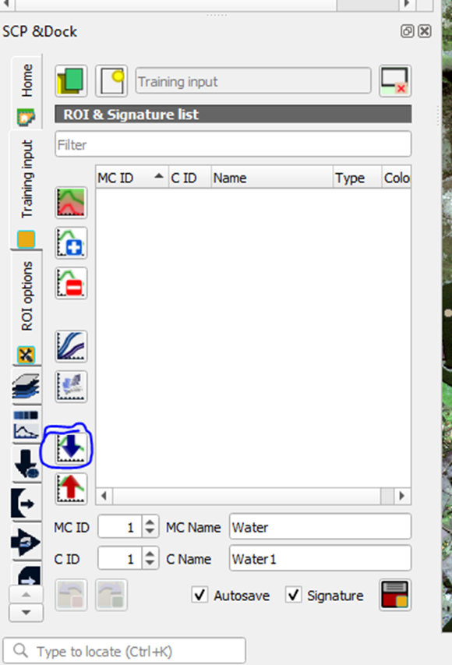**Importing Training Data**

